SDLC Models: Agile, Waterfall, V-Model & Spiral Model
Software Development Life Cycle (SDLC) models define structured approaches for planning, designing, building, testing, and delivering software. Different models suit different types of projects depending on requirements, risk levels, timelines, and flexibility needed.
Below are four widely used SDLC models.
- Agile Model

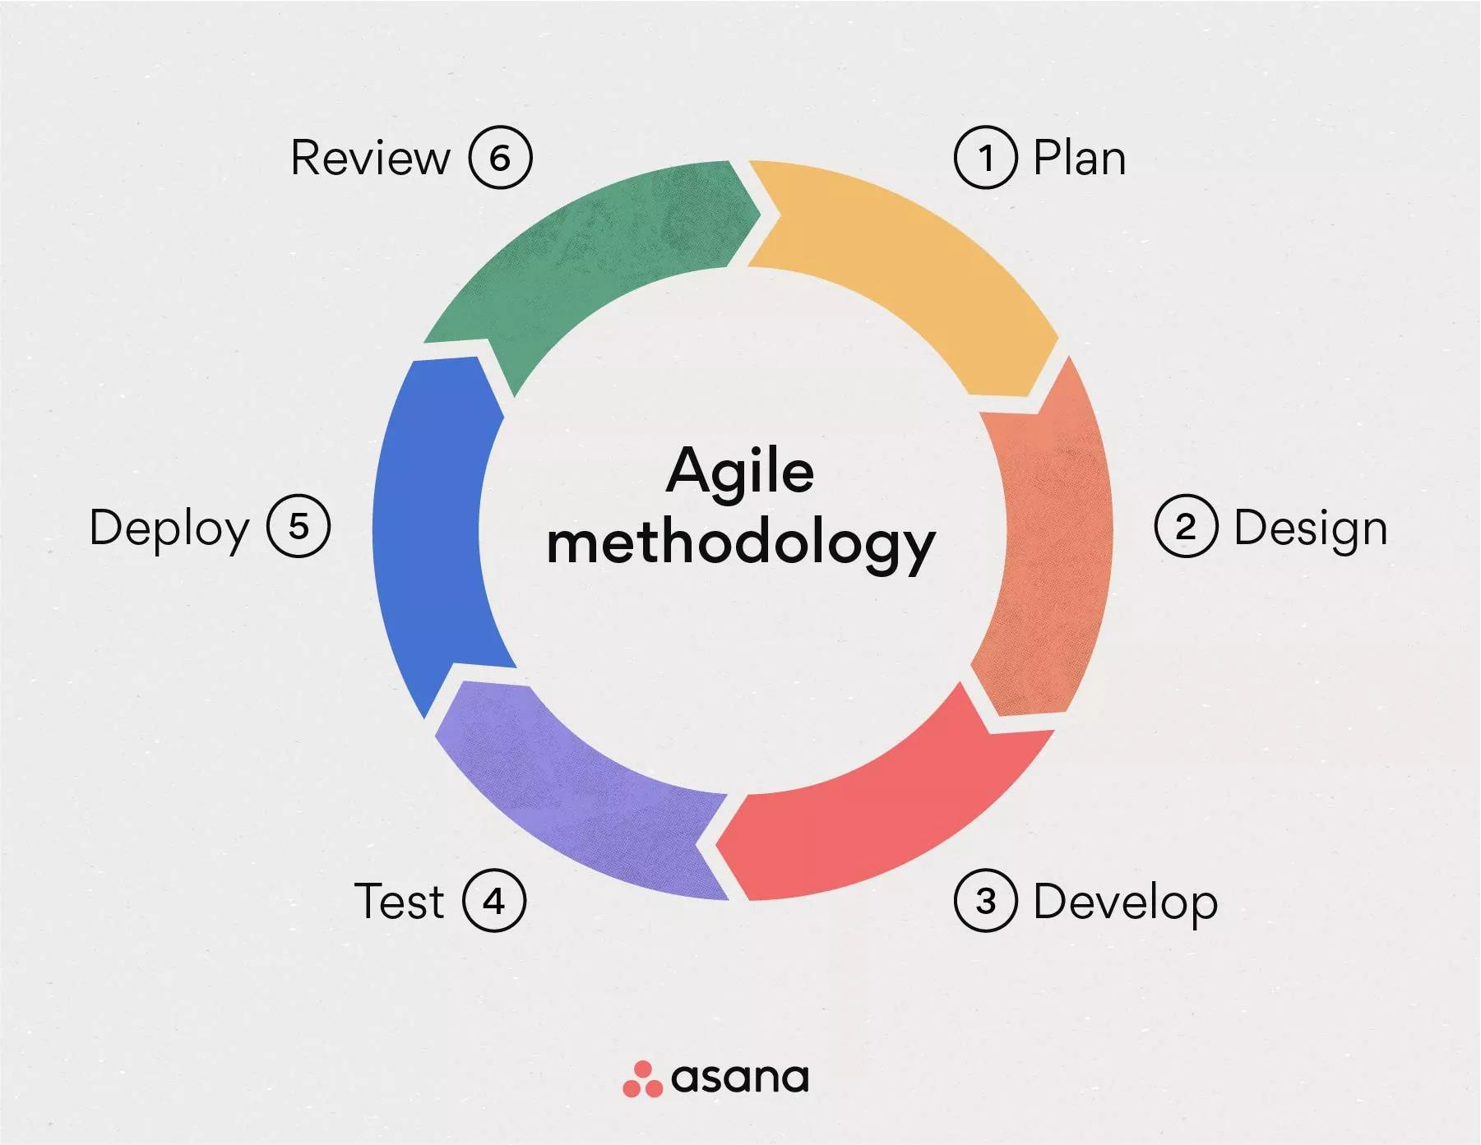

Overview
Agile is a modern, flexible, and iterative approach to software development. It breaks the project into small units called sprints, typically 2–4 weeks long. After each sprint, a working product increment is delivered and evaluated.

Key Characteristics
- Short, iterative cycles
- Continuous customer involvement
- Frequent testing and feedback
- Welcomes requirement changes at any stage

Best Suited For
- Projects with changing or unclear requirements
- Fast-paced product environments (apps, web platforms)
- Teams needing continuous updates and quick releases

Pros
- High adaptability
- Early delivery of usable software
- Better collaboration and transparency

Cons
- Requires experienced teams
- Hard to predict final cost and timeline
- Can become chaotic without proper discipline

- Waterfall Model

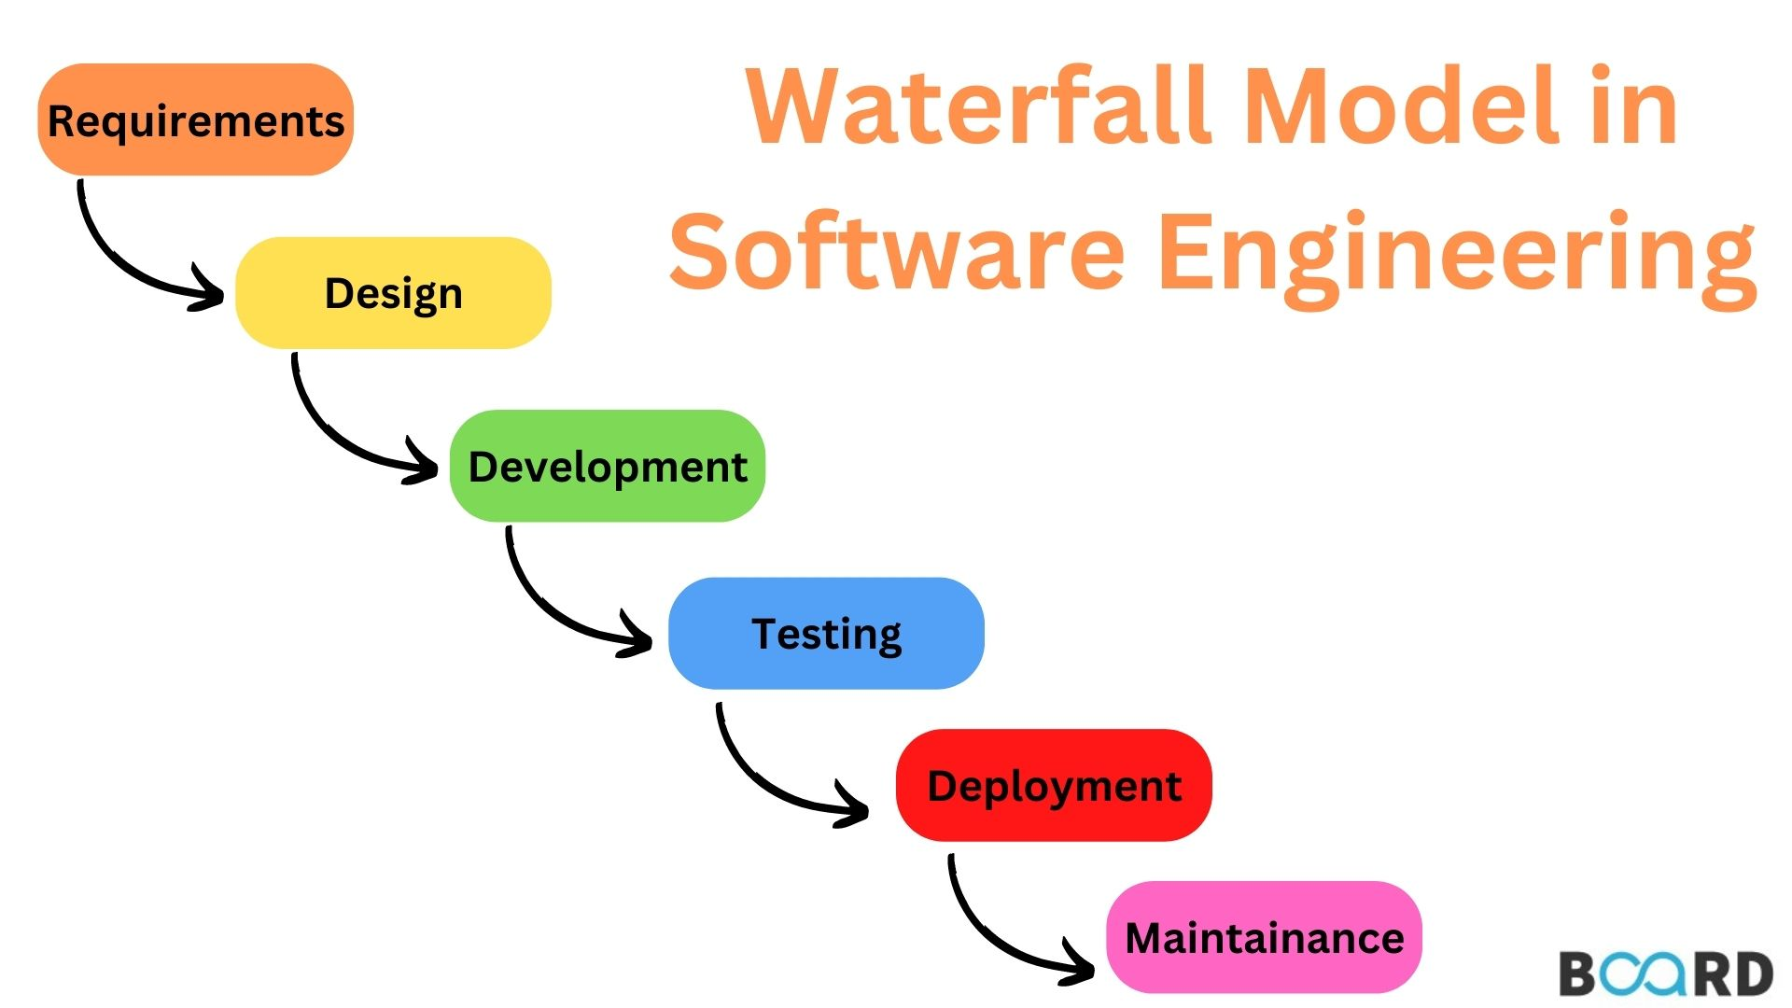

Overview
The Waterfall Model is the oldest SDLC approach, following a step-by-step, linear flow. One phase must be completed before the next begins, similar to water flowing downward.

Phases
- Requirement Analysis
- System Design
- Implementation
- Integration & Testing
- Deployment
- Maintenance

Best Suited For
- Small projects with fixed requirements
- Government or contract-based projects
- Projects where documentation is essential

Pros
- Simple and easy to manage
- Clear structure and documentation
- Easy to understand for beginners

Cons
- Very rigid — changes are difficult
- Testing occurs late in the lifecycle
- Not suitable for long-term or evolving projects

3. V-Model (Verification & Validation Model)

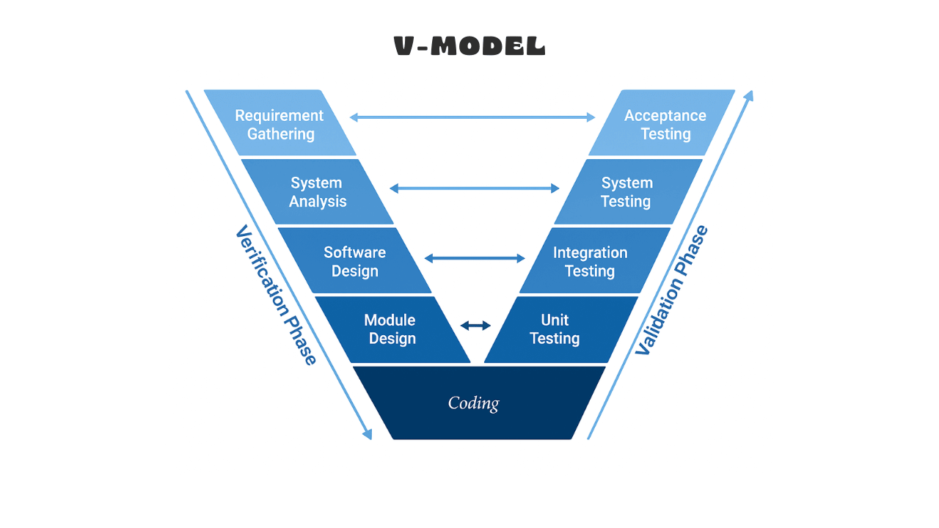

Overview
The V-Model is an enhancement of the Waterfall Model. For every development activity on the left side of the “V”, a corresponding testing activity exists on the right side. It ensures that testing starts early and runs parallel with development.

Structure
Left Side — Verification:
- Requirement Analysis
- System Design
- Architectural Design
- Module Design
Right Side — Validation:
- User Acceptance Testing
- System Testing
- Integration Testing
- Unit Testing

Best Suited For
- Large systems where quality is critical
- Medical, aerospace, defense, and banking applications

Pros
- Early detection of defects
- Strong emphasis on quality assurance
- Well-structured and disciplined approach

Cons
- Very rigid, similar to Waterfall
- High cost and more documentation
- Not ideal for dynamic requirements

4. Spiral Model

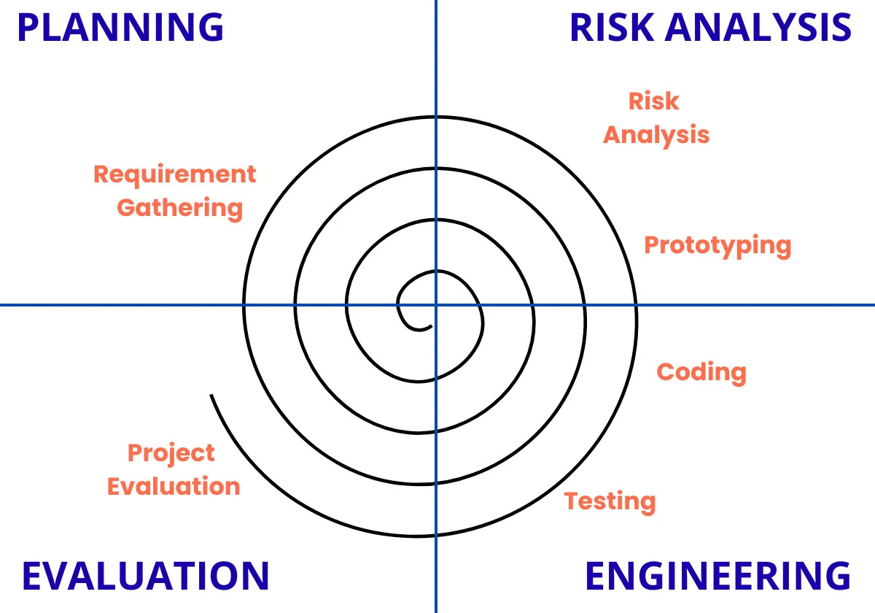

Overview
The Spiral Model combines elements of iterative development and risk analysis. The project passes through repeated cycles known as spirals, each containing four main stages.

Each Spiral Consists Of
- Planning: Identify requirements
- Risk Analysis: Detect and reduce risks
- Engineering: Design, develop, and test
- Evaluation: Customer feedback and refinement

Best Suited For
- Large, high-budget, high-risk projects
- Complex systems requiring continuous refinement

Pros
- Strong risk management
- Flexibility similar to Agile
- Customer involvement at every stage

Cons
- Expensive and time-consuming
- Needs expert project management
- Not suitable for small projects

Conclusion
Each SDLC model serves a unique purpose:
- Waterfall: Simple, structured, but rigid
- V-Model: Quality-focused, testing-driven
- Spiral: Risk-driven, iterative for large projects
- Agile: Flexible, fast, and customer-centric

